实验报告

课程名称 | java课程设计 | 班级 | 大数据2204 | 学号 | 8210222526 |  | 姓名 | 曹家赫
实验名称 | 实验5 字符串与输入输出 |  |  | 实验时间 |  | 第 13 周
实验环境
Eclipse/Jcreator Pro/JDK。
实验目的和内容要求
一、实验目的
- 掌握字符串常用函数的使用方法。
- 了解输入输出的基本原理；掌握类File、FileInputStream、FileOutputStream、RandomAccessFile的使用方法。
二、实验要求
- 提供所完成的各道题主要实验代码和运行结果的界面截图。
- 简述在实验过程中遇到的问题与解决方法。
- 简述实验过程中的发现与收获，未解决或需进一步解决的问题。
三、实验内容
- 输入一个字符串，将其中的大写英文字母改为小写字母，小写字母改为大写字母，然后输出。
- 检查输入的字符串是否是“回文”，例如“abc123321cba”就是回文。
- 输入两个字符串，从第一个字符串中删除第二个字符串的内容。
- 从命令行方式输入的字符串中删去所有重复的字符，每种字符只保留一个。
- 统计一个字符串中给定字符串出现的频率。
- 将一个表示十进制数的字符串转换为以逗号分隔的字符串，从右边开始每三个数字标一个逗号。例如，给定一个字符串“1234567”，该方法返回“1,234,567”。
- 求2~200之间的所有素数，将求得的结果保存到PRIME.DAT文件中。
- 检查C盘根目录下CONFIG.
- SYS文件是否存在，若在则显示该文件的名称和内容。
- 输入5个学生的信息（包含学号、姓名、3科成绩），统计各学生的总分，然后将学生信息和统计结果存入二进制数据文件STUDENT.DAT中。
- 从第（10）题中建立的STUDENT.DAT文件中读取数据，寻找平均分最高的学生，并输出该学生的所有信息。

实验过程、结果分析与总结
1.import java.util.Scanner;

class Test {
public static void main(String[] args) {
Scanner sc = new Scanner(System.in);
System.out.println("请输入一个字符串：");
String str = sc.nextLine();
sc.close();
StringBuilder sb = new StringBuilder();
for (int i = 0; i < str.length(); i++) {
char ch = str.charAt(i);
int ascii = (int) ch;
if (ascii >= 65 && ascii <= 90) {
sb.append((char) (ascii + 32));
} else if (ascii >= 97 && ascii <= 122) {
sb.append((char) (ascii - 32));
} else {
sb.append(ch);
}
}
System.out.println("转换后的字符串为：");
System.out.println(sb.toString());
}
}
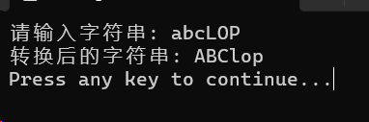
}

2.import java.util.Scanner;

public class homework5_1 {
public static void main(String[] args) {
Scanner scanner=new Scanner(System.in);
System.out.print("请输入字符串: ");
String input=scanner.nextLine();
boolean isPalindrome = checkPalindrome(input);
if (isPalindrome) {
System.out.println("是回文字符串");
} else {
System.out.println("不是回文字符串");
}
}

public static boolean checkPalindrome(String input) {
int left=0;
int right=input.length()-1;
while (left < right) {
if (input.charAt(left)!=input.charAt(right)) {
return false;
}
left++;
right--;
}
return true;
}
}
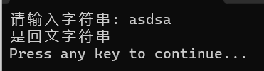
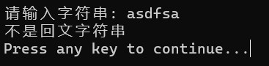
3.import java.util.Scanner;

public class homework5_1 {
public static void main(String[] args) {
Scanner scanner=new Scanner(System.in);
System.out.print("请输入第一个字符串: ");
String str1=scanner.nextLine();
System.out.print("请输入第二个字符串: ");
String str2=scanner.nextLine();
String result=deleteSubstring(str1, str2);
System.out.println("删除结果: "+result);
}

public static String deleteSubstring(String str1,String str2) {
return str1.replace(str2,"");
}
}
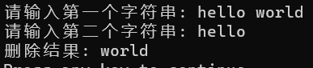
4.import java.util.Scanner;

public class homework5_1 {
public static void main(String[] args) {
System.out.println("请输入一个字符串（以空格分割）：");

Scanner scanner=new Scanner(System.in);
String input=scanner.nextLine();
char[] chars=input.toCharArray();
int[] count=new int[128]; // 创建一个字符计数器

for (char c:chars) {
count[c]++;
}

StringBuilder result=new StringBuilder();
for (char c='A;c<='Z;c++) {
if (count[c]==1){
result.append(c);
}
}
for (char c='a;c<='z’;c++){
if (count[c]==1) {
result.append(c);
}
}
System.out.println("删除重复字符后的结果：");
System.out.println(result.toString());
}
}
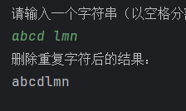
5.import java.util.Scanner;

public class homework5_1 {
public static void main(String[] args) {
Scanner scanner = new Scanner(System.in);
System.out.print("请输入字符串: ");
String input = scanner.nextLine();
System.out.print("请输入要统计的子字符串: ");
String substring = scanner.nextLine();
int frequency = countFrequency(input, substring);
System.out.println("子字符串出现的频率: " + frequency);
}

public static int countFrequency(String input, String substring) {
int frequency = 0;
int index = input.indexOf(substring);
while (index != -1) {
frequency++;
index = input.indexOf(substring, index + 1);
}
return frequency;
}
}
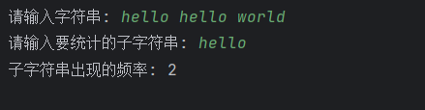
6.import java.util.Scanner;
public class homework5_1 {
public static void main(String[] args) {
Scanner scanner=new Scanner(System.in);
System.out.print("请输入一个表示十进制数的字符串: ");
String input=scanner.nextLine();
String result=addCommas(input);
System.out.println("转换后的字符串: "+result);
}
public static String addCommas(String input) {
StringBuilder result=new StringBuilder();
int length=input.length();
int digits=0;
for (int i=length-1;i>=0;i--){
result.insert(0,input.charAt(i));
digits++;
if (digits%3==0 && i!= 0) {
result.insert(0,",");
}
}
return result.toString();
}
}
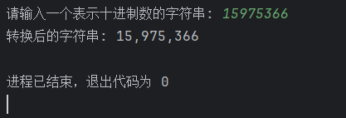
7.import java.io.BufferedWriter;
import java.io.FileWriter;
import java.io.IOException;

public class PrimeNumbers {
public static void main(String[] args) {
StringBuilder primeNumbers = new StringBuilder();
for (int i = 2; i <= 200; i++) {
if (isPrime(i)) {
primeNumbers.append(i).append("\n");
}
}
saveToFile(primeNumbers.toString(), "PRIME.DAT");
System.out.println("素数已保存到文件 PRIME.DAT");
}

public static boolean isPrime(int number) {
if (number <= 1) {
return false;
}
for (int i = 2; i <= Math.sqrt(number); i++) {
if (number % i == 0) {
return false;
}
}
return true;
}

public static void saveToFile(String content, String filename) {
try (BufferedWriter writer = new BufferedWriter(new FileWriter(filename))) {
writer.write(content);
} catch (IOException e) {
e.printStackTrace();
}
}
}

8.import java.io.File;

public class CheckFileExistence {
public static void main(String[] args) {
String filePath = "C:\\CONFIG.SYS";
File file = new File(filePath);
if (file.exists()) {
System.out.println("文件存在: " + file.getName());
} else {
System.out.println("文件不存在: " + file.getName());
}
}
}

9.import java.io.File;
import java.io.IOException;
import java.nio.file.Files;
import java.nio.file.Paths;

public class CheckFileExistenceAndContent {
public static void main(String[] args) {
String filePath = "C:\\CONFIG.SYS";
File file = new File(filePath);
if (file.exists()) {
System.out.println("文件存在: " + file.getName());
try {
String content = new String(Files.readAllBytes(Paths.get(filePath)));
System.out.println("文件内容:\n" + content);
} catch (IOException e) {
e.printStackTrace();
}
} else {
System.out.println("文件不存在: " + file.getName());
}
}
}
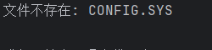
10.import java.io.FileOutputStream;
import java.io.IOException;
import java.io.ObjectOutputStream;
import java.io.Serializable;
import java.util.ArrayList;
import java.util.List;
import java.util.Scanner;

class Student implements Serializable {
private String id;
private String name;
private int score1;
private int score2;
private int score3;

public Student(String id, String name, int score1, int score2, int score3) {
this.id = id;
this.name = name;
this.score1 = score1;
this.score2 = score2;
this.score3 = score3;
}

public String getId() {
return id;
}

public String getName() {
return name;
}

public int getScore1() {
return score1;
}

public int getScore2() {
return score2;
}

public int getScore3() {
return score3;
}

public int getTotalScore() {
return score1 + score2 + score3;
}
}

public class homework5_1{
public static void main(String[] args) {
List<Student> students = new ArrayList<>();
Scanner scanner = new Scanner(System.in);

for (int i = 0; i < 5; i++) {
System.out.println("请输入第 " + (i + 1) + " 个学生的信息：");
System.out.print("学号: ");
String id = scanner.nextLine();
System.out.print("姓名: ");
String name = scanner.nextLine();
System.out.print("科目1成绩: ");
int score1 = Integer.parseInt(scanner.nextLine());
System.out.print("科目2成绩: ");
int score2 = Integer.parseInt(scanner.nextLine());
System.out.print("科目3成绩: ");
int score3 = Integer.parseInt(scanner.nextLine());

Student student = new Student(id, name, score1, score2， score3);
students.add(student);
}

try (FileOutputStream fileOutputStream = new FileOutputStream("STUDENT.DAT");
ObjectOutputStream objectOutputStream = new ObjectOutputStream(fileOutputStream)) {
objectOutputStream.writeObject(students);
System.out.println("学生信息已保存到文件 STUDENT.DAT");
} catch (IOException e) {
e.printStackTrace();
}
}
}
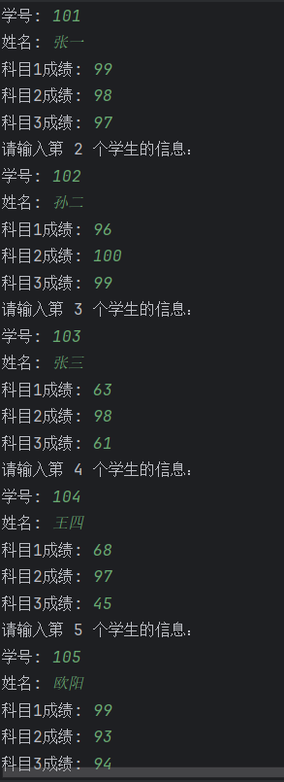
11.import java.io.FileInputStream;
import java.io.IOException;
import java.io.ObjectInputStream;
import java.util.List;

public class homework5_2{
public static void main(String[] args) {
List<Student> students = readStudentData("STUDENT.DAT");
if (students != null) {
Student highestAverageScoreStudent = findStudentWithHighestAverageScore(students);
if (highestAverageScoreStudent != null) {
System.out.println("平均分最高的学生信息：");
System.out.println("学号: " + highestAverageScoreStudent.getId());
System.out.println("姓名: " + highestAverageScoreStudent.getName());
System.out.println("科目1成绩: " + highestAverageScoreStudent.getScore1());
System.out.println("科目2成绩: " + highestAverageScoreStudent.getScore2());
System.out.println("科目3成绩: " + highestAverageScoreStudent.getScore3());
System.out.println("平均分: " + highestAverageScoreStudent.getTotalScore() / 3.0);
} else {
System.out.println("找不到学生信息或学生数据为空.");
}
} else {
System.out.println("读取学生信息失败.");
}
}

public static List<Student> readStudentData(String filename) {
try (FileInputStream fileInputStream = new FileInputStream(filename);
ObjectInputStream objectInputStream = new ObjectInputStream(fileInputStream)) {
List<Student> students = (List<Student>) objectInputStream.readObject();
return students;
} catch (IOException | ClassNotFoundException e) {
e.printStackTrace();
return null;
}
}

public static Student findStudentWithHighestAverageScore(List<Student> students) {
if (students.isEmpty()) {
return null;
}

Student highestAverageScoreStudent = students.get(0);
double highestAverageScore = highestAverageScoreStudent.getTotalScore() / 3.0;

for (int i = 1; i < students.size(); i++) {
Student student = students.get(i);
double averageScore = student.getTotalScore() / 3.0;
if (averageScore > highestAverageScore) {
highestAverageScore = averageScore;
highestAverageScoreStudent = student;
}
}

return highestAverageScoreStudent;
}
}

指导老师评阅意见
指导老师： 年 月 日
填写内容时，可把表格扩大。

